Assignment 2 Worksheet

Aim
To implement and understand different techniques for detecting cycles in a linked list and finding the starting point of a cycle.

Objectives
- To detect a cycle using a HashSet.
- To detect a cycle using Fast and Slow Pointers.
- To implement Floyd's Cycle Detection Algorithm.
- To find the starting node of a cycle.
- To compare the time and space complexity of different approaches.

Question 1: Cycle Detection Using HashSet

Problem Statement
Given the head of a linked list, determine whether the linked list contains a cycle using a HashSet.

Algorithm
- Create an empty HashSet.
- Start from the head of the linked list.
- Check whether the current node is already present in the HashSet.
- If it is present, a cycle exists.
- Otherwise, add the node to the HashSet.
- Move to the next node.
- If None is reached, no cycle exists.

Program
class ListNode:
def __init__(self, val=0, next=None):
self.val = val
self.next = next

def hasCycle(head):
slow = head
fast = head

while fast and fast.next:
slow = slow.next
fast = fast.next.next

if slow == fast:
return True

return False

head = ListNode(1)
head.next = ListNode(2)
head.next.next = ListNode(3)
head.next.next.next = ListNode(4)

head.next.next.next.next = head.next

if hasCycle(head):
print("Cycle detected")
else:
print("No cycle")
Expected Output:
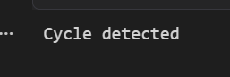

Complexity
Complexity | Value
Time | O(n)
Space | O(n)

Question 2: Cycle Detection Using Fast and Slow Pointers

Problem Statement
Given the head of a linked list, determine whether a cycle exists using Floyd's Cycle Detection Algorithm.

Algorithm
- Initialize two pointers:
  - slow at the head.
  - fast at the head.
- Move slow one node at a time.
- Move fast two nodes at a time.
- If slow and fast meet, a cycle exists.
- If fast reaches None, there is no cycle.

Program
class ListNode:
def __init__(self, data):
self.data = data
self.next = None

def detect_cycle(head):
slow = head
fast = head

while fast is not None and fast.next is not None:

slow = slow.next
fast = fast.next.next

if slow == fast:
return True

return False

head = ListNode(1)
node2 = ListNode(2)
node3 = ListNode(3)
node4 = ListNode(4)
node5 = ListNode(5)

head.next = node2
node2.next = node3
node3.next = node4
node4.next = node5

node5.next = node3

if detect_cycle(head):
print("Cycle detected using Floyd's Algorithm")
else:
print("No cycle detected")
Expected Output:
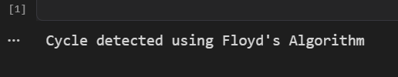

Complexity
Complexity | Value
Time | O(n)
Space | O(1)

Question 3: Find the Start of the Cycle

Problem Statement
Given the head of a linked list, find the node at which the cycle begins. If there is no cycle, return None.

Algorithm
- Initialize slow and fast at the head.
- Move slow one step and fast two steps.
- If they do not meet, there is no cycle.
- If they meet, move slow back to the head.
- Move both slow and fast one step at a time.
- The node where they meet is the starting point of the cycle.

Program
class ListNode:
def __init__(self, data):
self.data = data
self.next = None

def find_cycle_start(head):

slow = head
fast = head

while fast is not None and fast.next is not None:

slow = slow.next
fast = fast.next.next

if slow == fast:
break

else:
return None

slow = head

while slow != fast:

slow = slow.next
fast = fast.next

return slow

head = ListNode(1)
node2 = ListNode(2)
node3 = ListNode(3)
node4 = ListNode(4)
node5 = ListNode(5)

head.next = node2
node2.next = node3
node3.next = node4
node4.next = node5

node5.next = node3

start = find_cycle_start(head)

if start is not None:
print("Cycle starts at node:", start.data)
else:
print("No cycle found")
Expected Output:
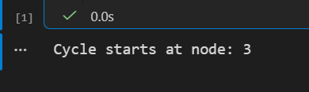

Complexity
Complexity | Value
Time | O(n)
Space | O(1)

Learning Outcomes
After completing this assignment, students will be able to:
- Understand the concept of cycles in linked lists.
- Implement cycle detection using a HashSet.
- Implement Floyd's Fast and Slow Pointer algorithm.
- Find the starting point of a linked-list cycle.
- Analyze time and space complexity.
- Compare memory-based and pointer-based approaches.

